Ch 15. Crown-rots, Root-rots, and Vascular WIlts
Kingdom: | Fungi | Fungi | Fungi | Fungi | Fungi | Fungi
Phylum: | Ascomycota | Ascomycota | Ascomycota | Basidiomycota | Ascomycota | Ascomycota
Class: | Sordariomycetes | Sordariomycetes | Dothideomycetes | Agaricomycetes | Pezizomycetes | Sordariomycetes
Order: | Hypocreales | Hypocreales | Botryoshaeriales | Atheliales | Pezizales | Xylariales
Family: | Nectriaceae | unresolved | Botryosphaeriaceae | Atheliales | Rhizinaceae | Xylariaceae
Genus: | Fusarium | Verticillium | Macrophomina | Sclerotium | Phymatotrichopsis | Dematophora
Species: | F. solani, F. oxysporum, F. sulphurem, F. avenaceum, F. graminearum. | V. dahliae, V. albo-atrum | M. phaseolina | S. rolfsii | P. omnivora | D. nectrix

Fusarium
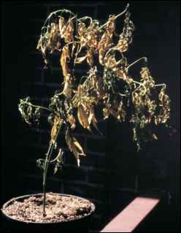
Figure 15.1. Cannabis plant severely affected by Fusarium wilt caused by Fusarium oxysporum. Photo by J. McPartland.

Introduction
Of the fungal pathogens that infect commercial cash crops, there is none more devastating than those caused by vascular wilts. Wilting is a condition where plants lose turgor pressure in their cells due to lack of water, which can be caused by abiotic or biotic factors. Vascular wilt is a general term for the symptom caused by various disease organisms that block the vascular tissue in plants, thereby restricting water flow from roots to other areas of the plant.
Vascular wilts are most frequently a problem for large scale cultivators outdoors. Fusarium is a genus of soil borne fungi that can wreak havoc on a wide variety of plants. In particular, Fusarium oxysporum can cause wilt among Cannabis. Fusarium is most frequently identified in hemp fields, though this is most likely only due to the scale and geographic range of the hemp where hemp is now grown. Fusarium diseases may also be more common than recognized, as many people are not familiar with the symptoms and appearance of this pathogen.
Some of the organisms that cause Fusarium wilt in Cannabis can also infect other host plants, so be aware of the plants you have near your Cannabis plants. Other hosts include coffee, tobacco, alfalfa, and soybeans. Since these fungi can spread so rapidly, early identification of this disease is of utmost importance.
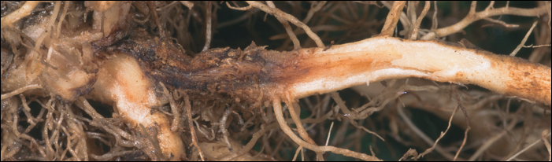
Figure 15.2. Tomato plant displaying characteristic symptoms of ‘foot rot’ where the reddening of the vascular tissue near where the stem meets the soil caused by Fusarium fungus.

Symptoms of Fusarium pathogens are typically described as an overall wilting of the plant. If the fungus is causing ‘foot rot’ the plant stems can have a brownish appearance at the soil line. Spots will begin to appear, first on lower, more mature leaves. Spots will appear in between leaf veins and will quickly spread to the newer tissue. Eventually, leaf tips will curl up before the plant succumbs to a wilt. Therefore, the traditional classification of Fusarium wilt is fitting for this disease.
The U.S. and state governments have researched Fusarium oxysporum pathovars as biocontrols capable of wiping out plantations of Erythroxylum coca (the source of cocaine) Papavera somniferum (Opium Poppy) and Cannabis (https://sciweb.nybg.org/science2/hcol/fusarium2.asp.html, K. S. Tiourebaev et al 2010 (biological control of ditchweed). Apparently, the fungus was successful at destroying entire crops in trials. They even developed specific pathovars intended to attack specific host species. However, concern about this pathogen being able to jump to other host plants and cause economic and ecological damage prevented widespread application for biocontrol purposes. Ultimately, Fusarium supposedly was never sprayed in field applications, though there have been accusations the U.S. government used Fusarium as biocontrol of Coca in Peru (which the government denies).
Besides such malicious introductions, Fusarium may be naturally present in a region's soil, or dispersed into a garden via wind borne spores, imported soil and transplant rootballs, and carried by people and equipment. Regardless of where it comes from, certain environmental conditions are conducive to Fusarium growth, permitting this pathogen to grow and multiply at an alarming rate.
Punja and Rodriguez showed that Fusarium oxysporum and F. solani can infect Cannabis roots in a hydroponic system, and although infected plants did not always have wilting symptoms, the exposed plants did display stunted root growth and development (Punja and Rodriguez 2018). They also noted in the same study that plants grown in soil systems that were exposed to the pathogen are more likely to show typical wilt symptoms due to being in a more challenging environment for roots to access nutrients, when compared to a hydroponically grown crop.

Biology & Lifecycle
Fusarium species are in the phylum Ascomycota. This means they produce their ascospores in sacs and have septate hyphae without clamp connections. The sexual fruiting body is a perithecia (singular perithecium), though abundant asexual conidia are also readily produced.

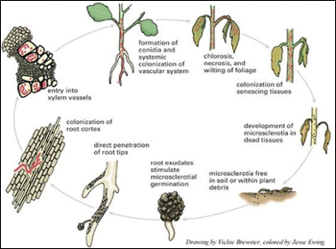
Figure 15.3. Life cycle of typical Fusarium species.

The lifecycle of Fusarium begins with a sexual or axesual spore. This spore will germinate when conditions are met and a hypha with one type of nucleus (monokaryotic) will emerge. Remember, there may be many nuclei in each hypha but at this point there is only one type of nucleus. Since Fusarium can grow saprophytically on dead material, it can grow, multiply, and persist without the presence of living host plants. When a suitable host plant is sensed, the fungus will grow toward the roots. Once contact occurs, the fungus will produce an appressorium in order to gain access to living host tissue. The fungus can also enter through wounds in the root or via the delicate root tip cells.
Shortly after the fungus invades the root, it will grow into the xylem tissue, which is what the plant uses for conducting water from the roots up to the shoots of the plant. The fungus enters the xylem through the pit cells. Continuing upward, the fungus colonizes more and more of the plant, using the xylem as the mode of transport while also strangeling the plant of water, causing its characteristic wilt. Fusarium can also make microcondia. These microconidia are carried through the xylem by means of sap flow and can then germinate and infect even more areas of the plant. When the plant is dead Fusarium will grow out of the xylem and into other areas of plant tissue. Certain conditions make it so the fungus is able to proliferate very quickly. This fungus prefers warmer temperatures, sometimes symptoms will not be observed until the temperature reaches 26C.

Prevention & Treatment
Growers can act preventatively to alter their growing environment to be less hospitable to the Fusarium pathogen by avoiding or remedying wet areas with poor drainage (McPartland et al. 2000). Excess nitrogen fertilizer has also been shown to lead to increase in fungal pathogen infestation (Krnjaja et al. 2021) as has deficient nitrogen concentrations (Lemmens et al. 2004, Heier et al. 2005) . Fusarium pathogens can exist in a wide range of environments and can live as saprophytes, feeding on dead organic matter, until the appropriate host presents itself and then acts as a pathogen. Unlike many other soil-borne pathogens, Fusarium species are aerobic organisms that require oxygen to survive. Therefore, compact, anaerobic soils are not likely to foster Fusarium (or grow healthy Cannabis).
Due to the aerobic nature of Fusarium prolonged field flooding has been used to reduce Fusarium wilt with variable success (Evaluation of Soil Solarization and Flooding As Management Tools for Fusarium Wilt of Lettuce, 2010). Liming acidic soils may decrease the chance of Fusarium infection (McPartland et al. 2000). Heat treatments via solarization or steam treatments can be used to treat infected soil before use. Depending upon temperature and duration of the treatment, you can sterilize the soil, which will kill the fungal spores (along with everything else), or pasteurize it to allow a population of saprophytic antagonists to persist (Cook 1985).
Plow-under cover-crops can be used to increase competition against Fusarium by non-pathogenic soil saprophytes. Brassicaceae plow-under crops have further efficacy against Fusarium due to the antifungal effects of isothiocyanates, released by mustard greens when they break down (See Section 4.X). Brassica plow-under crops should be immediately incorporated into the soil following mowing, or else the antimicrobial isothiocyanates will escape as gas without making contact with soil pathogens. Remediating an entire field infested with Fusarium will be difficult and may require several years. Crop rotation can also help reduce disease load, though it is unlikely eliminate Fusarium from a field on its own.
If a plant is identified to be infected with Fusarium it is recommended to quickly remove and destroy the plant, or destroy it in place, to reduce amplification and spread of the pathogen rather than attempting to treat infected plants. Burn the plant debris after destroying it, or use a flameweeder to remove the plant. If a plant is left to the point where the fungus is releasing spores, the entire field could now be contaminated for future plantings. Movement of infected material, or soil from infected areas of the field (such as on shoes and equipment) can spread the pathogen throughout a field.

Verticillium
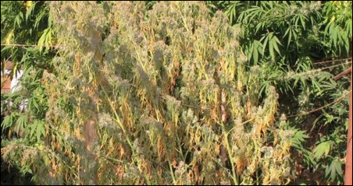
Figure 15.4. Verticillium species infecting a large Cannabis plant.

Introduction
Verticillium dahliae and V. albo-atrum have both been shown to cause wilt in Cannabis plants (McParland 1996, Ranalli 1999). This fungal infection looks very similar to wilt caused by Fusarium and would really take further investigation to identify the true culprit. Virticillium wilt is a systemic disease, where the fungus can travel in the xylem and cut off water flow to certain areas of the plant. When cut into the stem, one will typically see a reddish-brown discoloration in the xylem tissue where the fungus was beginning to grow (McPartland 1996).
Although traditionally there have not been many reports of Verticillium impacting Cannabis farms, one would expect to see the rates of incidences to increase with the exponential growth of Cannabis being cultivated around the world in native soils.
The two species of Verticillium that are reported to infect Cannabis are also able to colonize a vast array of other host plants. Verticillium dahliae is more common and persistent in soils and has a larger number of hosts that it lives off. Its hosts include cotton, potato, tomato, eggplant, and more. Verticillium albo-atrum has fewer susceptible hosts, one of which is hops, Humulus lupulus, which is a close relative of Cannabis (in same family Cannabaceae).

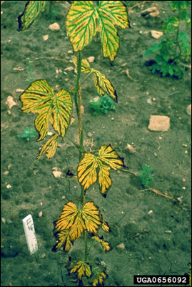
Figure 15.5. Verticillium wilt ‘tiger stripe’ symptoms manifesting on hop plant.

As noted previously, superficial plant symptoms are very similar to Fusarium wilts, with several small distinctions. Pacific Northwest Pest Management Handbook states that in addition to leaves turning yellow and dying, some leaves would actually display a ‘tiger stripe’ leaf pattering, similar to that seen in hops (Fig. 3). The entire plant may show symptoms simultaneously or it may appear as though only one or a few branches are infected.
Chlorotic yellow leaves and unnecessary wilting in combination with reddish-brown vascular tissue when the stem is cut in are all indicators of Verticillium wilt. Microslerotia and/or conidia are often found in the xylem when lateral cross-sections are made. Often microscopic and/or molecular techniques are required to positively identify this pathogen is the agent of cause.

Biology & Lifecycle
Verticillium is a genus of soil borne Ascomycete fungi, some of which can infect Cannabis by entering the root. Found in soils mainly as either microsclerotia or dark hyphae, these specialized structures rely on the presence and detection of root exudates before they begin to germinate. Once germinated, the hyphae will begin to grow towards the root cell.The fungus can enter the host tissue either from a wound or opening in the root tissue or by producing a specialized structure that allows the fungus to enter the root. Once in the root, the wilt fungus will move towards the tube-like vascular system of the plant that allows the plant to transport nutrients (phloem) and water (xylem) throughout the plant. Verticillium wilts have a particular affinity towards the xylem tissue, which is dead at maturity.
The fungus can travel as mycelium, conidia, or specialized resting structures known as microsclerotia. If the fungus gets stopped by a blockage in the xylem, mycelium will grow around it and digest the plant tissue and then sporulate on the other side of the blockage and continue to access the rest of the plant. The fungi has not been observed entering the phloem.

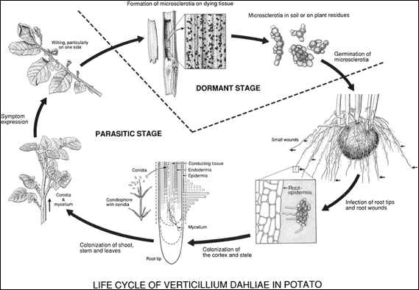
Figure 15.6. Life cycle of Verticillium dahliae on potato plant (Keykhasaber et al 2017).

Once inside the xylem the fungus can move throughout the plant very quickly, especially since the fungus will often produce conidia for the mode of transport which allows for much greater speeds of dispersal. It is worth noting that the hyphae found within the host vascular tissue is typically linear and unbranched. The fungus will spread and continue to steal nutrients from the plant, acting as a true parasite and killing the plant.
After the fungus has killed the plant by stealing nutrients and blocking water movement, the plant will have died. At this point Verticillium fungi can begin to act as saprotrophs, colonizing and digesting the dead host tissue.
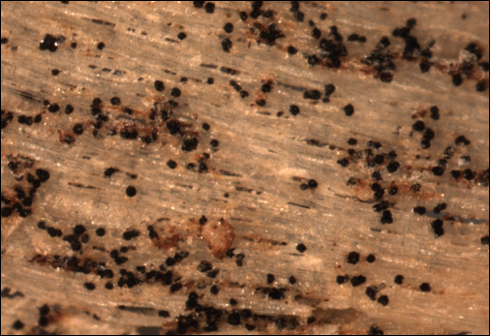
Figure 15.7. Verticillium microsclerotia embedded in woody tissue of Acer spp.

Verticillium will form a resting structure either as microsclerotia (V. dahliae) or as dark-colored hyphae (V. albo-atrum) that typically is found within the vascular tissue of the now dead host plant. The microsclerotia are thick, melanized structures that allow V. dahliae to persist in harsh environments for long periods of time until the right conditions and host is found (Fig. X). The dark melanized hyphal cells are also resting structures but are not able to withstand adverse environments for as long as the microsclerotia. Therefore V. dahliae is able to persist in soils longer and is more common than V. albo-atrum (Mace 2012). These fungi have been found in almost all types of soils, and can survive in a wide variety of environments (Mace 2012).

Prevention and Treatment
Remediating a field of soil that has a population of Verticillium can be very difficult. Soil fumigation with Methyl Bromide and Chloropicrin has been the conventional chemical approach for decreasing population number but is not recommended unless severe measures are needed and other methods have ceased to work (Duniway 2002). Such practices will destroy the biology and structure of your soils which can take a long time to recover. Due to its toxicity, Methyl Bromide is only permitted for use under a critical use exemption granted by the EPA. Chloropicrin (nitrochloroform) has good efficacy at treating fungal diseases in soil on its own. Originally developed as a tear gas for chemical warfare, chloropicrin has acute toxic effects to humans. However, it degrades relatively rapidly in light with a half life of several hours to a week (CA EPA, 2013). California implemented buffer zones for its use following bystander exposures of 25 to over 1000 feet, depending on the type of tarp used during soil fumigation or if it is applied untarped. 1, 3 Dichloropropene is also an effective fungicidal soil fumigant, though similar concerns with toxicity exist for this compound and the EPA lists it as a probable human carcinogen (EPA 2000).
Other potential options for removing or reducing Verticillium species from your fields include crop rotation, however, due to the broad host range of these pathogens, it is sometimes difficult to find a crop that is not susceptible (Klosterman et. al 2009). Researchers have noted that broccoli is not very susceptible to Verticillium wilt and may make an logical choice for crop rotation in contaminated fields, but more investigation is required (Bhat and Subbarao 2001).
Anaerobic soil disinfection (ASD), where a high carbon source is applied to the soil and then a tarp is placed over the area to deplete the oxygen and create an anaerobic environment, is another non-chemical technique for limiting Verticillium (Washburn 2018). The concept with this method is to provide ample food resources for microbe populations while depriving the soil of air exchange (Blok et al. 2000). As the microbes consume the food they deplete oxygen levels, eliminating or greatly decreasing the population of aerobic pathogens, like Verticillium.
Pullman et al. have researched a technique known as ‘soil solarization’ where the farmer uses a clear tarp to essentially cook the soil with the heat of the sun, eliminating a large population of pathogenic organisms, as well as the beneficial ones (Pullman et al. 1981). This is an interesting treatment option, particularly for farmers that are looking for non chemical options. However, there are obvious limitations on the last two methods, depending on the size of the farm, geographic location, and pathogen population to name a few.
Another treatment that has been researched is incorporating brassica residue into the soil. Broccoli is rich in glucosinolates, which are broken down by soil microorganisms, releasing by-products such as isothiocyanates, thiocyanates, and nitriles (Bhat and Subbarao 2001). The resulting toxic compounds may possess fungicidal properties that can potentially decrease the pathogen population or atleast make them less active. This phenomena is known as biofumigation. Perhaps other plant species with elevated concentrations of glucosinolates would offer similar results.
In fact, in 2003 McGuire researched using mustard greens as a cover crop and to grow a green manure that would be terminated and incorporated back into the soil while the plants were still green. Again, mustard greens are a brassica high in glucosinolates that breakdown into potential toxic compounds in the soil. Not only did the Veticillium levels decrease, but incorporating the green manure also improved water infiltration and saved the farmers a substantial amount financially from not having to purchase and apply chemical pesticides.
As always, having best management practices in place in regards to cleanliness and soil health is imperative when growing highly valuable cash crops. Doing regular applications of high quality, biologically active compost will help inoculate fields with beneficial microorganisms that can help protect plants from pathogens. Planting or breeding resistant cultivars can also greatly reduce crop loss to Verticillium wilt (Keykhasaber et al. 2017)

Macrophomina

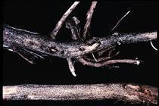
Figure 15.8. Microsclerotia of Macrophomina phaseolina growing on the root of a soybean crop.

Introduction

Also known as charcoal rot, Macrophomina phaseolina is yet another Ascomycete fungus that causes a number of diseases in crops, including vascular wilts. This fungus has a broad host range, with the ability to infect over 500 different plant species (Khan 2007). In addition to charcoal rot, M. phaseomina has been reported to cause damping off, basal stem rot, root rot, and seedling blight (Ijaz 2013).
Wilt from M. phaseolina can have symptoms similar to other wilt diseases, however, the pathogen may be latent and symptoms may not appear until later in the plants life (Ijaz 2013). This disease produces an array of symptoms including reduced emergence and yield, severe wilting, yellowing of leaves, chlorosis, necrosis, loss of vigor and more (Kunwar et al. 1986).
However, a tell-tale sign that this is the fungus infecting plants is if the epidermis of the plant stem is peeled off, there may be the presence of tiny black, tuber-like structures which are microsclerotia formed by the fungus (Fig. _).

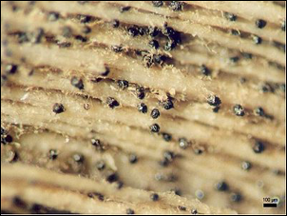
Figure 15.9. Microsclerotia of Macrophomina phaseolina in fibrovascular plant tissue after epidermis has been peeled.

Macrophomina phaseolina has been documented on a number of crops, in a wide variety of environments and geographical locations (Akhtar 2011). It can be transmitted through soil, the roots of transplanted plants, or even on the seed coat of particular plants (Khan 2007).
Particular care should be given when working in fields or near plants that have charcoal rot fungus. Macrophomina phaseolina has been documented as a human pathogen, particularly in immunocompromised patients (Srinivasan et al 2009). As we learn more about the various plant pathogens (and even just soil organisms in general) we may find that more and more of these organisms are able to invade susceptible human hosts as well as crops.

Biology & Lifecycle

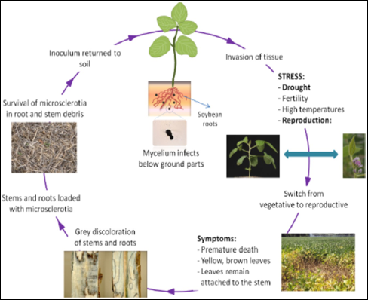
Figure 15.10. Lifecycle of Macrophomina phaseolina from Zafari et al. 2018.

Although initially this fungus begins as a spore, for our purposes we will begin with the microsclerotia. A microsclerotium is a small mass of cells that develop a melonized wall around the outside of the structure for protection. This allows fungi to survive harsh conditions for extended periods of time. For M. phaseolina the microscleriotia can be thought of as the infective stage of the fungus.
The microsclerotia can persist in soils anywhere from 2-15 years, depending on the conditions (Meyer et al. 1974). Then, when a susceptible crop is planted into a field containing M. phaseolina and the plant begins to release root exudates, microsclerotia near the root will begin to germinate. The fungus relies on this signal from the plant in order to grow and invade the roots.
Once the fungus has germinated it will begin to grow towards the roots. The mycelium will either enter the root through a wound or opening, or the fungus will produce an appressorium that will enter the plant cell either through mechanical forces or through enzymatic digestion. After invading the host tissue, M. phaseolina is mainly contained in the intercellular spaces of the root cortex cells (Gupta et al. 2012). However, in 1987, Burton et al. noticed that infection on cantaloupe plants mainly occurred on secondary and tertiary roots. Perhaps the fungus invades secondary roots and then is able to travel to the primary roots where the fungus is able to live and persist. Regardless, unlike other wilt causing organisms, M. phaseolina affects the fibrovascular system of the plants, opposed to just infecting the vascular system.
This fungus can travel through the vascular system of plants, mainly in the form of microsclerotia. Mycelia and microsclerotia can clog vascular tissue, cutting off the plant's supply of water and nutrients. The can manifest as black/grey mold in the vascular system, hence the name ‘charcoal rot’.
Eventually adjacent cells will begin to die, either from a loss of water and nutrients or from phytotoxic compounds that the fungus is producing (Rahemi et al. 2007). Macrophomina may act as a latent disease, where the fungus infects crops but they appear asymptomatic for a period of time, and then when conditions are right the symptoms express. Therefore, diagnosing this disease without the help of molecular techniques can be very difficult.
Gupta et al. noted that in some plant species, the plant switching to reproductive growth (flowering) could initiate the fungus to produce more microsclerotia in the plant vascular tissue. The microsclerotia will persist as the plant dies and remains in the plant residue until it is decomposed, at which point the microsclerotia will be left in the soil, awaiting new susceptible crops.
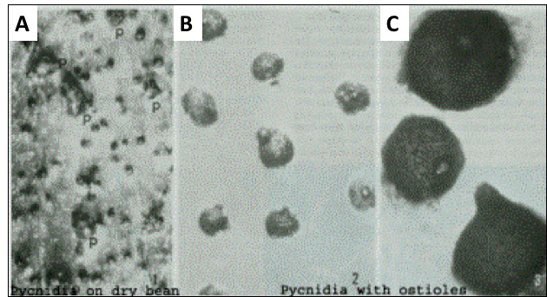
Figure 15.11. Macrophomina phaseolina sexual structures (pycnidia). A) is pynidia on a bean, B) is pycnidia and C) is a closeup of the pycnidia, showing the ostioles.

When M. phaseolina does produce a sexual structure, it is a pycnidium. Pycnidia are round, dark structures that house the asci that produce ascospores. This is the ‘fruiting body’ of this particular fungus and is where sexual reproduction takes place. When the ascospores are fully developed within the asci, the sacs will burst and the spores will be released through the ostioles, which is a neck with an opening at the end. Researchers have noticed that M. phaseolina only produces pycnidia in certain hosts under particular conditions or in vitro under particular laboratory conditions (Gupta et al. 2012, Gaetán et al. 2006).
Regardless of the fungus producing pycnidia or not, the fungus typically persists in the soil in the form of microsclerotia. The mycelia is not considered the major source of inoculum, but the microsclerotia are. So if you have noticed that plants have been infected with charcoal rot, it is important to get that plant and its residues out of the field before the microsclerotia re-enter the soil.

Prevention and Treatment

As always, being aware of the field you are farming and the crops you are growing can greatly alleviate any future pains of dealing with this fungus. As stated previously, M. phaseolina can persist in soils as microsclerotia anywhere from 2-15 years, depending on environment/weather/crops grown/etc. In addition to surviving long periods in soil, there is also evidence that M. phaseolina can spread via the seed coat in certain crops (Kunwar et al. 1986). It has not yet been confirmed if this can happen in Cannabis crops.
There are a number of synthetic pesticides that farmers are using to try to mitigate and control charcoal rot. Many of these compounds are powerful antifungal compounds that most likely will kill the pathogen, but are not very selective and will also kill any other fungi that the compounds come in contact with. This could have serious environmental, ecological and economical implications and would only be recommended in extreme cases where all other measures have failed.
There are, however, factors that do influence the rate of infection and yield loss to this pathogen. The overall health of the plants and how much stress they are under (abiotic and biotic), will impact the susceptibility to this fungus (Burton et al. 1987). In 1995, Diourte et al. found soil moisture and stress from high temperatures and drought to influence the rate of infection as well.
If M. phaseolina is already present in the soil and you must grow a Cannabis crop in this field, there are several options as far as reducing the pathogen populations and increasing the chance for success. Soil fumigation is a somewhat common practice in conventional soybean fields. However, less intensive methods include crop rotation, soil solarization, and perhaps even various organic amendments and changing the C:N ratio (Israel et al. 2005).
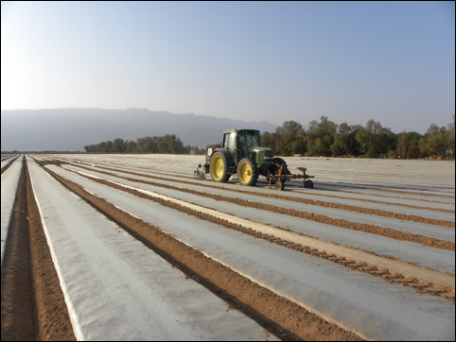
Figure 15.12. Tractor applying polyurethane mulch after field has been tilled and water for soil solarization to reduce pathogen levels

Crop rotations can be difficult due to the diverse number of crops that this fungus can infect. Soil solarization also shows promise but again, would likely kill everything in the soil that is not heat tolerant and capable of surviving periods of time with little to no oxygen. Adding organic amendments such as, mustard oil cake, has been shown to be effective at control the pathogen as well (Israel et al. 2005).
Bio-control options have also been researched for controlling or reducing the populations of M. phaseolina in soils (Elad et al. 1986, Arora et al. 2001, Singh et al. 2008, Gupta et al. 2011). Some of the biocontrol agents that showed promise were; Rhizobioum meliloti, Trichoderma harzainum, and Bacillus subtilis.
Avoiding soils that have known populations of M. phaseolina is the number one way to reduce your chances of getting this pathogen. However, good practices such as soil health and cleanliness will always help reduce root pathogens. Developing resistant varieties through rigorous breeding practices can also greatly help the industry as a whole reduce yield loss to wilt fungi but will take time and hard work.

Athelia rolfsii (formerly Sclerotium)

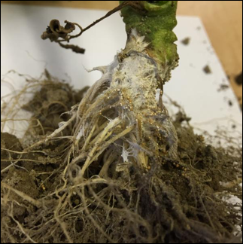
Figure 15.13. Southern Blight (Athelia rolfsii) growing on a tomato root stock.
Introduction
A particularly interesting fungus that has been found to infect Cannabis is Sclerotium rolfsii (Teleomorph: Athelia rolfsii). When the pathogen was originally discovered, which was from a diseased tomato plant in Florida, it was not realized that this is the same fungus that forms a corticoid crust fruiting bodies. Therefore, the original name for the organism that causes ‘Southern Blight’ was S. rolfsii, but, since the advent of molecular techniques and the realization of the sexual state, the fungus has been moved to the genus Athelia and the name has been changed to A. rolfsii.
Due to this fungus’ predilection for warm climates, and being discovered from Fl, the common name given to the fungal pathogen is ‘Southern Blight’. Although called Southern Blight, A. rolfsii can cause damping off in seedling or wilt/blight symptoms in more mature plants. Wilts are typically characterized by drooping due to loss of water whereas blights typically affect leaves, flowers, fruits or other parts of the plant. Therefore there are a variety of symptoms that can be an expression of A. rolfsii infection.
Also known as ‘mustard seed fungus’, A. rolfsii is a facultative pathogen, meaning that in addition to surviving off susceptible host plants, this fungus can also act as a soil saprotroph, digesting organic matter from dead plant residues. This allows A. rolfsii to survive and grow in soils even when there are no hosts present.
After the food source has run out, Southern Blight can also produce sclerotia to persist in harsh conditions when the environment is not favorable. Again, this is a strategy employed by a number of pathogenic fungi that make them difficult to eliminate from soils.
As the sclerotia germinate, A. rolfsii can infect plants of all ages. If seedlings are infected, damping off can occur. If vegetative plants are infected, wilt or blight traits can be expressed. If the plant is in its reproductive growth phase, more wilt/blight-like symptoms can manifest. Often water-logged lesions can appear on the leaf tissue or stems of the plant, typically near the base of the plant where the stem meets the soil.
Southern Blight has been shown to attack about 500 species of host plants in the United States alone (Flores-moctezuma et al. 2006). In addition to Cannabis, other susceptible plants include tomatoes, sugar beets, peanuts, soybeans, and many others. Grasses such as switchgrass and corn seem to be overall less susceptible and may be logical candidates for crop rotations (Kator et al. 2015).
Menies reports that researchers have found slerotia to survive in soils without a host for at least 5 years under certain conditions (Menzies 1983). Being a facultative pathogen allows this organism to employ alternative strategies for obtaining nutrition, giving them a distinct advantage over other obligate pathogens.

Biology & Lifecycle
Athelia rolfsii is noteworthy among Cannabis pathogens in that it is a Basidomycete, meaning it is more related to a portabello than most of the fungal Cannabis pathogens discussed so far (Rhizoctonia is also a basidomycete). Althelia is a weakly pathogenic soil saprophyte. Affected plants exhibit lesions at the soil line. Though the infections are not systemic, the fungus can girdle the stem and kill the root system, resulting in total plant death.
Althelia rolfsii is generally only present as vegetative hyphae and sclerotia. The fungus survives in the soil indefinitely as a saprophyte on dead organic matter, and may persist as sclerotia during harsh conditions. When susceptible plants are present and conditions are favorable to the fungus, Althelia will attack living plants via direct contact of the mycelium with below ground portions of the host plant. The mycelium will come in proximity to the root and prior to penetrating the plant cell, the fungus will excrete enzymes that kill and even disintegrate the cell wall before contact (Faruk et al 2010).
Since this is not a systemic disease, the fungus does not travel within the body of the plant. Instead A. rolfsii will begin to kill plant cells and then digest the nutrients and will continue to do this until the plant is dead, at which point the fungus will continue to consume the dead plant material.
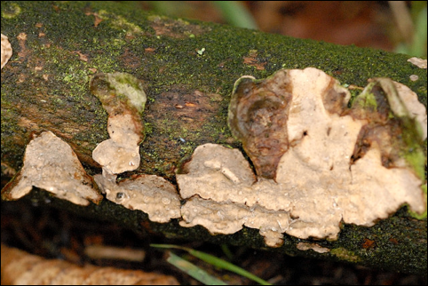
Figure 15.14. Example of a corticoid crust fungus Phanerochaete velutina, NOT Athelia rolfsii because no good pictures could be found of A. rolfsii in field conditions. This is the type of fruiting body that A. rolfsii will form.

Though rarely seen, Althelia rolfsii is capable of sexual spore formation. It is currently unknown what causes sexual reproduction in field conditions, however, under laboratory conditions nutrient concentration, light, and age of culture have all been shown to influence basidia formation. Since Athelia is in the phylum Basidiomycota and being in the corticoid, crust-fungus group, the sexual structures produced here are basidia that are on a flat, flush , fertile mat of hyphae. This is called a resupinate fruiting body.
The host range of Althelia is extremely broad, with over 500 plant species known to be affected. Despite its name, Southern blight is not restricted geographically, rather it thrives in warm, moist environments. It has been shown that freezing temperature will kill mycelia whereas sclerotia can persist through lower temperature.
The sclerotia of Southern Blight can vary dramatically in shape, size, and color. These structures can lie dormant until the correct environmental conditions present themselves. Biological analysis of field soil prior to plantings may help detect the presence of pathogenic organisms.

Prevention and Treatment
Southern blight is very difficult to eradicate and control once it has infected a field. Avoidance of infected fields and transfer of inocula via soil, people, and equipment is the first defense against this tenacious and persistent pathogen.
However, if Athelia is already present in the soils, farmers still have options for reducing or potentially eradicating the population. As previously mentioned, soil solarization can be an effective measure for reducing the pathogen numbers. Since Athelia is an aerobic organism that does not perform well in low oxygen environments, reducing oxygen levels make this pathogen less competitive. Other options to reduce oxygen are deep tillage and even flooding when appropriate.
Other options include crop rotations with non-susceptible host plants such as corn, sweet potatoes or cotton (Flores-moctezuma et al. 2006). However, care and strategic planning must be employed when attempting to reduce pathogen numbers with crop rotation, especially with A. rolfsii due to the diversity in host plants but also because this fungus can exist as a soil saprophyte as well.
If individual plants show symptoms, the plant and the soil around it should be removed and incinerated. Trichoderma, a fungal hyperparasite, and high nitrogen soil amendments have also been shown to be effective at reducing Althelia.

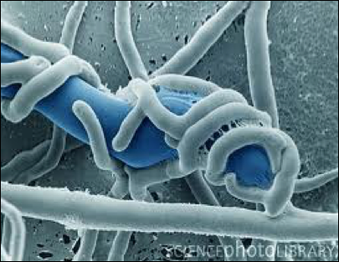
Figure 15.15. Trichoderma species parasitizing unknown fungal hyphae.

Trichoderma species such as T. harzianium and T. koningii can act as mycoparasites, parasitizing the mycelia and/or the sclerotia (Latunde-dada 1993). Therefore, Trichoderma have been researched as a biocontrol against A. rolfsii with promising success, depending on a number of variables (Elad et al. 1984, Punja 1985, Latunde-dada 1993). Researchers have noted that sclerotia germination is declined when other soil microorganisms are present, so perhaps increasing the soil biology by inoculating with high quality compost can help suppress Southern Blight as well (Punja 1985).
High levels of nitrogen application, including nitrogen supplements that will be converted into NH3 (ammonia) seem to have a reducing effect on pathogen populations. This could be due to toxic ammonia levels or it could be contributed to an increase in soil microbiology activity or in plant innate immunity changing, or a million other variables that we are not currently considering.
An interesting last note about the relationship between Athelia and Cannabis is that when researchers Farooq et al. were examining ways to control theis fungus, they experimented with a number of different plant extracts. One of the plant extracts they included that showed activity against A. rolfsii was the extract of Cannabis sativa (Faruk et al 2010).

